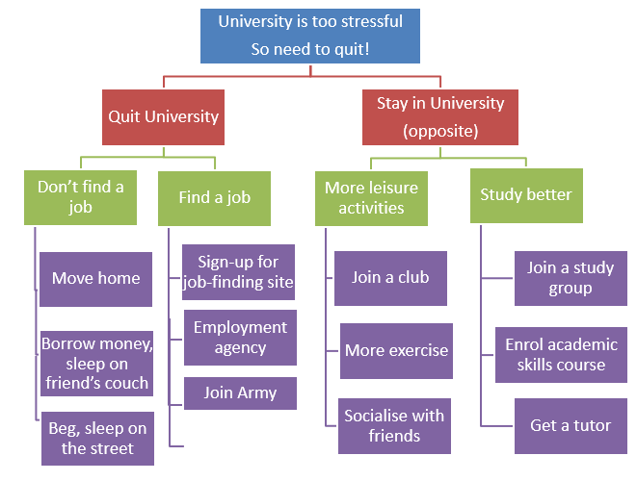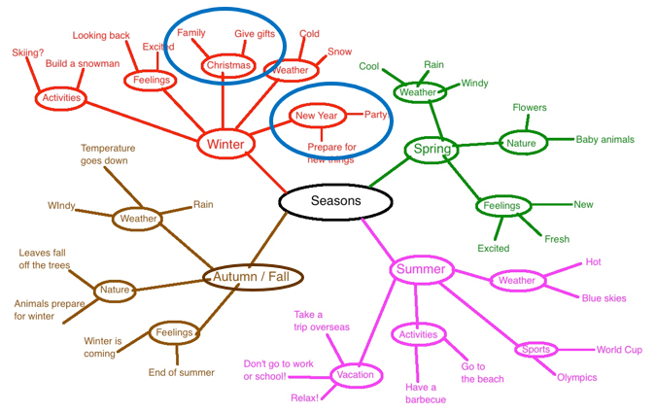Engineering Process Duncker diagram

MindMap

Step 1 – The problem

Step 2 – Define Success

Constraints, performance criteria

Political, cost, environment

Step 3 – Find solutions

Duncker, mindmap, fishbone

Step 4 – Test

Step 5 – Decide - Kepner-Tregoe

Weights table

Step 6 – build and deliver

Step 7 – operate

Step 8 – end of life

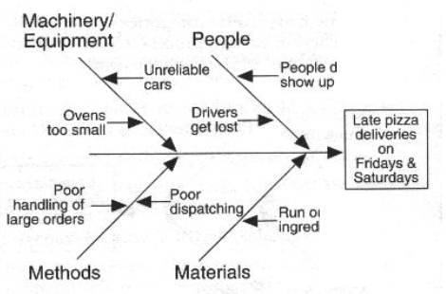Tables: caption above- detailed, referenced before

Fishbone

The frictional pressure drop can be calculated from the velocity, as follows:

∆Pf = 4fL/D*ru2/2 (1)

The frictional pressure drop DPf is related to the pipe length (L) and fluid density (ρ) (Eq. 1).

Figures: caption below- no border or title

Units, headings, labels, consistent formatting and font size

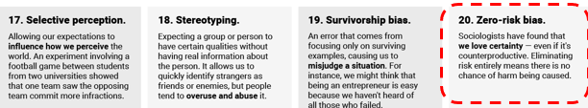

**Risk** = hazard * probability * consequence

Can’t eliminate all hazards

To Find FAR:

Find deaths/yr

Divide by people/yr

Scale to 1000 people

Scale to 35 years

Can’t make probability zero

Can’t eliminate all consequences

FAR = deaths/1000 people/105 hours

105 hours = 35 work years

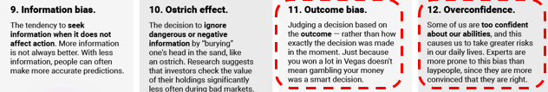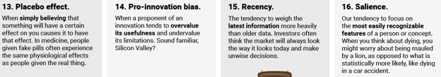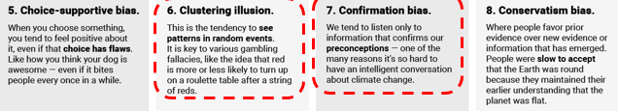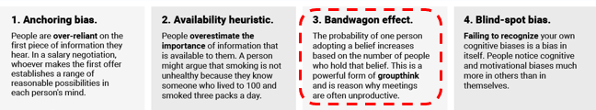

Motueka wastewater treatment plant upgrading – constructability, financially viable, acceptable to local iwi, tolerate variable flow rates, provide sufficient treatment, acceptable to local community and industry – iwi wanted treated water must flow through land before being released to a river or ocean, not affect food gathering in Golden Bay

TRAMPOLINE

4 themes – technology, market, business, finance

Requirements – larger, higher, must break down for packaging,

Canadian attitude – go big or go home

Requirements for US:

Round tube, enclosed safety net, smaller breakdown for packaging, samples for shows

TEAMWORK

One of our teammates isn’t working hard enough or their work is poor, We had a lot of work to do in the last day and one teammate wasn’t available, One of our team members is not meeting deadlines or is skipping meetings

My team doesn’t like me even though I do what they ask, The group was unhappy with my work but didn’t tell me

We are having a problem with our teammate and the report is due in a few days.

My teammates like to procrastinate but I need to get things done early (or the reverse). **highly effective team** is more productive than a group of individuals working independently. Not all teams are effective!

Ethics

Rule based thinking – Do the right thing – follow rules

Ends based thinking – Get the best outcome – achieve best outcome

Not matter the action that gets it there

Virtues based thinking – be a good person – values

Conflict with each other

Utilitarianism – best good for most people